# System Dynamics Assignment: Shared Fridge Problem

## Problem Identification

In this scenario, 2 roommates create a ‘tragedy of the commons[1]’ style of problem by prioritising their individual food wants, resulting in an excessive use of a shared fridge. The objective of the roommates is to enjoy a greater variety of foods through greater ‘fridge utilisation’ (having more different foods in the fridge for them to eat). The problems created here are: (1) a third roommate who uses the fridge irregularly finds themselves without their fair share of fridge space when they need it, and (2) an over-purchasing of groceries leads to greater food waste. The root of the problem is that the individual actions of the 2 roommates taken together creates negative externalities for third parties.

The objective of this model is to explain the system for those involved in the issue, ultimately reducing the self-serving actions that result in the problematic side-effects (waste; unfair fridge space distribution). Potential applications for this model could be through interventions such as those suggested in this report, or to foster an awareness for the key agents in the problem to escape the ‘tragedy’ (over-usage of the fridge).

The behaviour prompting the model was the increasing food waste being observed and diminishing space left in the fridge for the third roommate. Figure 1 illustrates this, showing how roommates A and B quickly occupying more fridge space, slowing this trend as the fridge fills up. The slowdown in the rate of the trend hints that the roommates based their decision to increase fridge usage on the remaining capacity of the fridge. Food waste initially rises only when grocery purchases exceed consumption. It increases steadily from here until stabilizing at a constant rate.

## Model Structure

In creating the conceptual model, this report looks into how real-world system could be simplified to demonstrate the intended effect while remaining simple enough for the scope of this exercise. Figure 2 shows the conceptual structure this report follows, which is based off the tragedy of the commons system archetype, with a few changes to suit this report’s interpretation of the details of this system.

In the model, A and B work simultaneously but independently to buy increasing amounts of groceries each week, driven by their perceived benefits from maximising fridge utilisation. This forms the reinforcing loops, R1 and R2. Their procedure is to look at the remaining fridge capacity (their potential gain), and buy their previous amount of food plus enough to occupy a portion of the remaining fridge capacity next week (starting from an initial food purchase amount). A and B only purchase a portion of the remaining fridge capacity and not the entire remaining capacity here to better reflect the real behaviour of the system, though if they did purchase food to fill the entire remaining capacity then the problems would only be exacerbated.

The total utilisation for both A and B determines the remaining capacity (max capacity minus current use). Finally, the remaining capacity informs how much more A and B will buy next week (hence, the delay here). This completes the balancing feedback loops (B1 and B2).

The waste problem is demonstrated by this model through the ‘Food Waste’ which increases with the fridge utilisation by A and B. The decreasing ‘remaining capacity in the fridge’ shows how much capacity is available for use by roommate C, for our other problem. Roommate C themselves act as a bystander to the effects of this system and so are themselves excluded from the model.

## Create the Model on STELLA

(See model where each element is described in its description/annotation section)

The model is run for 84 days, which adequately shows all the patterns in the model’s behaviour. The mechanism used to replicate the feedback loops have been colour coordinated (see Figure 3). The elements that work together to create the reinforcing feedback effect are in green, while the balancing elements are in blue.

In creating the model on Stella, a further simplification was made that groceries are always bought on Sunday (every 7th day in the model) and all groceries expire and are thrown away on Saturday (every 6th day of 7). This simplification makes it easier to standardise the model’s output (as we avoid any time-dependent distributions) while not affecting the objective of the model.

## Behaviour of the Model

Some key graphs are shown in figure 4. The top-left chart gives a sawtooth pattern similar to inventory-level graphs with a regular level of demand and a regular supply at a given time interval. In this case, the peak of each tooth rises as the amount of food bought each Sunday (every 7th day) increases. This occurs until the limit (200L) is reached on day 49. This is mirrored by the red time-series on the bottom-left graph, which shows how A (with B acting the same) buys increasing amounts of groceries up to day 49.

From this point, groceries bought by A and B fill the fridge completely. After being filled, groceries are consumed at a constant rate; shown by the straight downward slope throughout the week until Saturday. On Saturday, all the contents of the fridge are thrown away and contribute to waste. On the top-right chart, waste starts to occur around day 27. It then reaches its maximum gradient on day 55 and rises by that same amount consistently every Saturday onwards. In reality all food in the fridge does not spoil evenly, so this time-series would be smoother.

The final graph (bottom-right) shows how the available space in the fridge behaves (a reflection of the first graph), giving roommate C less and less space to use the fridge if they ever wish to use it. The red line is used to show how A and B’s fridge use is eating into C being able to store the minimum amount of food for a week (the same value as A and B’s initial food purchase). Furthermore, in the real system there are cooked/prepared foods or food bought in mid-week shopping trips which might block C from having their share of space during the week between Sundays like in the model.

The reinforcing loops (R1 and R2 in Figure 2) are feeding into the mechanism by which the balancing loops (B1 and B2) stabilise the weekly amount of food in the fridge. Looking at it the other way around, the balancing feedback decreases the rate at which the reinforcing loops can drive greater and greater utilisations for A and B.

### Sensitivity Analysis

If the fridge’s maximum capacity were to be raised (as might be plausible if roommate C complained of a lack of space), then the limit would take longer to reach and result in gains for A and B as they can enjoy even more groceries in the fridge. If the fridge capacity were to be doubled, it would take A and B until day 63 for their combined food purchases reach the limit. However, this would also increase waste faster (as the rate at which food waste increases is allowed to increase further) and still result in C having limited fridge space, albeit after more time.

If the fridge capacity were to be lowered to 105, then food waste would be 0. However, this comes at the cost of A and B’s allowance of food and worsens the issue for roommate C who has their space taken even faster.

If the maximum consumption rate per day were to increase to approximately 29L of food per day, then waste would also be reduced to 0. This would also increase the rate at which the remaining capacity of the fridge declines after being stocked with groceries (see figure 5). This does not take away the problem that A and B’s purchasing habits eat into C’s share of fridge space, but it does reduce the time in the week where C is not able to store the necessary groceries for 1 person per week.

If the percentage of the remaining capacity that A and B would buy on their next shop were to increase to 60%, A and B would reach the full capacity of the fridge on their second shopping trip. This is because at time=0 (when the fridge is empty), there would be 200L of capacity remaining in the fridge. 60% of this would be 120L of additional groceries to buy. Adding this 120L to the 80L of initial food purchases made on the first Sunday (time=7) results in 200L of food purchases for the second Sunday (time=14).

If the groceries bought by A and B were limited to 80L each per Sundays’ food or less, then there would always be enough fridge capacity for C to store the ‘necessary groceries per week per person’. Furthermore, if they were limited to 66.6L of groceries per week then C’s equal share of fridge space could be entirely free to use.

## Simulation Experiments: Interventions

Three objectives guide this report’s intervention for the system: reducing food waste, allowing C a fair share of the fridge, and maintaining A and B’s benefits in fridge utilisation. Intervention targeting one objective must consider trade-offs for the others.

An interesting non-structural change would be to reduce the fridge size, which would reduce A and B’s ability to overstock on groceries, thereby reducing waste. This idea can be incorporated into the structural change to divide the fridge space evenly among roommates (such that they each are limited to 1 shelf of space). This would also ensure that C always has an equal share of the fridge to use.

In practice, this could be a very sensible solution. However, there are 2 problems this report highlights. Because of C’s lack of consistent usage of the fridge, the utilisation of the fridge by A and B (which is their goal) may be lowered at times where it doesn’t need to be. Also, if this policy is not enforced, A and B might use C’s space anyways as they see it is unoccupied. It also should be mentioned that this solution might work only if each divided section of the fridge is equal, not only in terms of space but utility (e.g., fridge door space can only store certain items).

This intervention can be further iterated on by making another change. A structural improvement would be to avoid one of the key assumptions of how A and B act in the system, that they act individually and with no communication or cooperation. If the roommates could communicate their intention to use fridge space differently than is typical, other roommates can accommodate this. This means that the fridge is used effectively. Furthermore, communicating to each other how much they buy for the shared fridge can help them track their combined groceries purchases and thereby avoid unnecessary food waste. A shared fridge/food-plan schedule or diary could be a policy suggestion to implement the desired structural change in the system.

Making these two structural changes (dividing fridge space and a shared plan or communication) to the system would allow A and B to maintain their fridge utilisation as much as possible while reducing waste and allowing C to have access to their space in the fridge whenever they desire to use it.

However, this would only be the solution to the problem as it appears in the model. In reality, enforcing fridge sections can be difficult as A and B would be incentivised to break set rules to optimise for the benefits in further fridge utilisation. Furthermore, planning and communications take time which creates trade-offs in other facets of A, B and C’s lives.

## Figures

Figure : Reference Mode showing remaining fridge space left for Roommate C and Food Waste increasing over time.

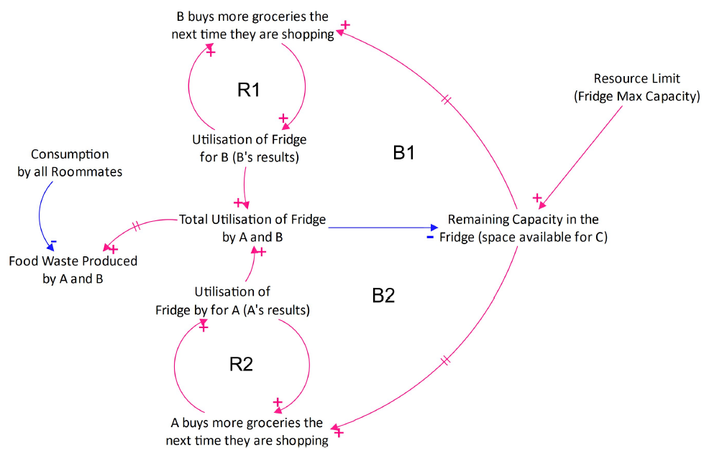Figure 2: Causal Loop Diagram for the fridge problem

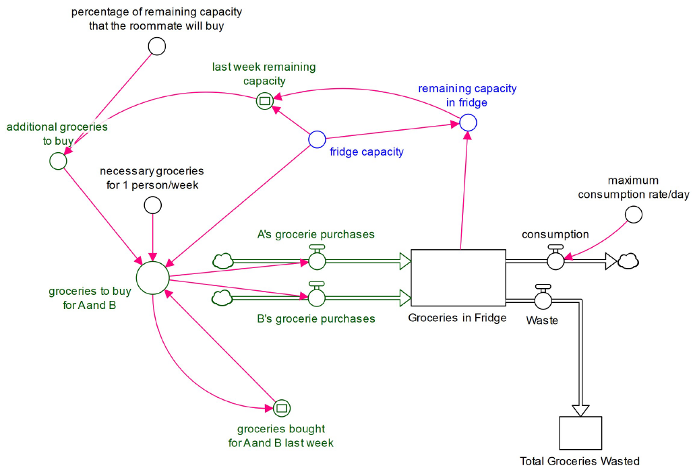

Figure 3: Stella Model for the problem in the CLD

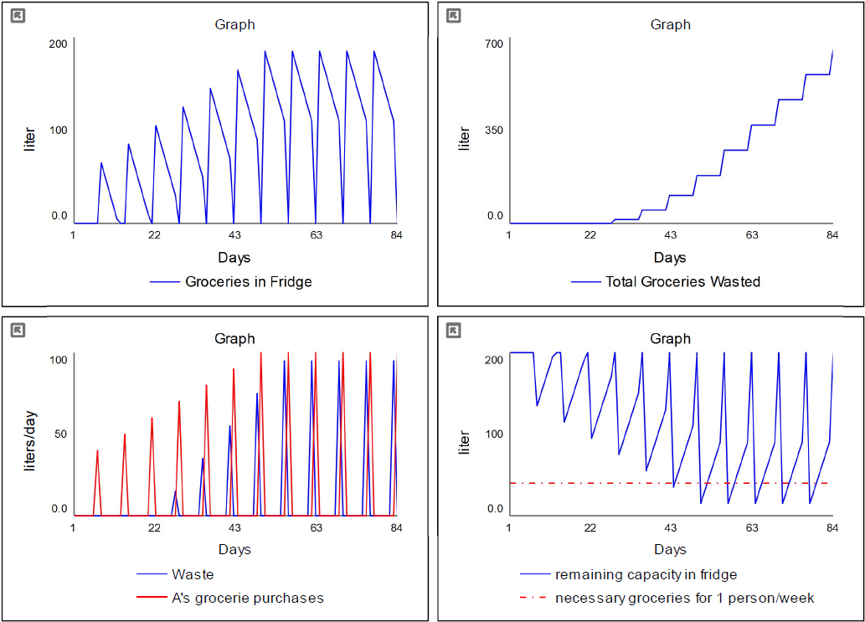

Figure 4: Stella output (emergent behaviours) shown through graphs.

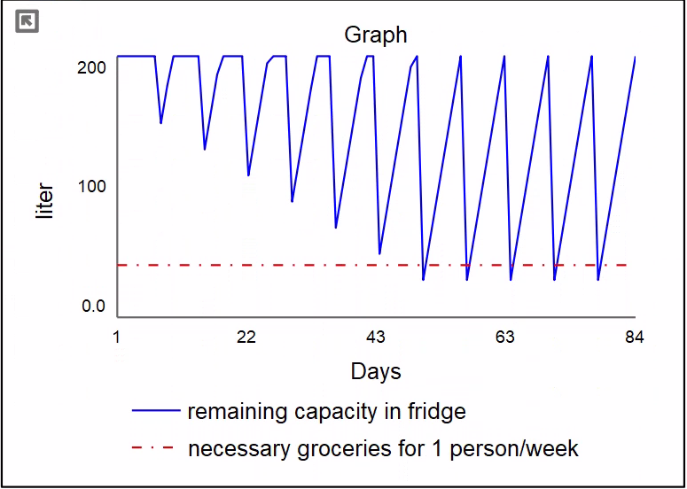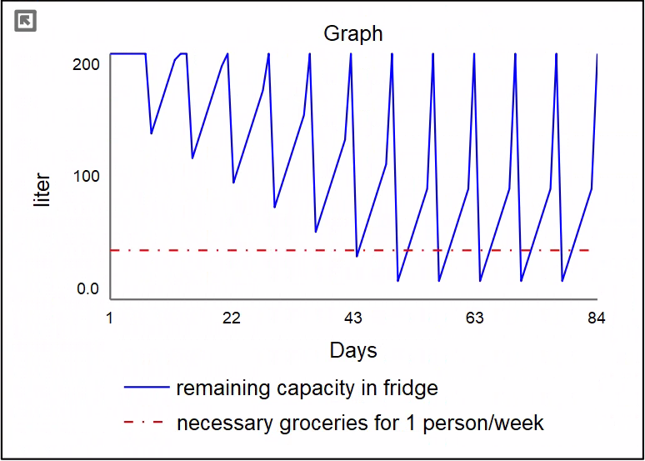

Figure 5: Remaining fridge capacity time-series comparison for consumption at 15L per day (left) and 29L per day (right).

1. Tragedy of the Commons is a popular system archetype. Read more at (<https://thesystemsthinker.com/tragedy-of-the-commons-all-for-one-and-none-for-all/>)